**Data** is defined as a collected group of information. Data collected may be age, name, a person’s opinion, type of pet, hair color etc. data is classified into two main classifications depending on its nature- namely categorical and numerical data. Categorical data, as the name implies, are usually grouped into a category or multiple categories. Similarly, numerical data, as the name implies, deals with number variables.

**Categorical data** is a collection of information that is divided into groups. Let’s understand the categorical data with different examples,

**Household income:** categorical data is mostly used by businesses when investigating the spending power of their target audience, to conclude on an affordable price for their products.

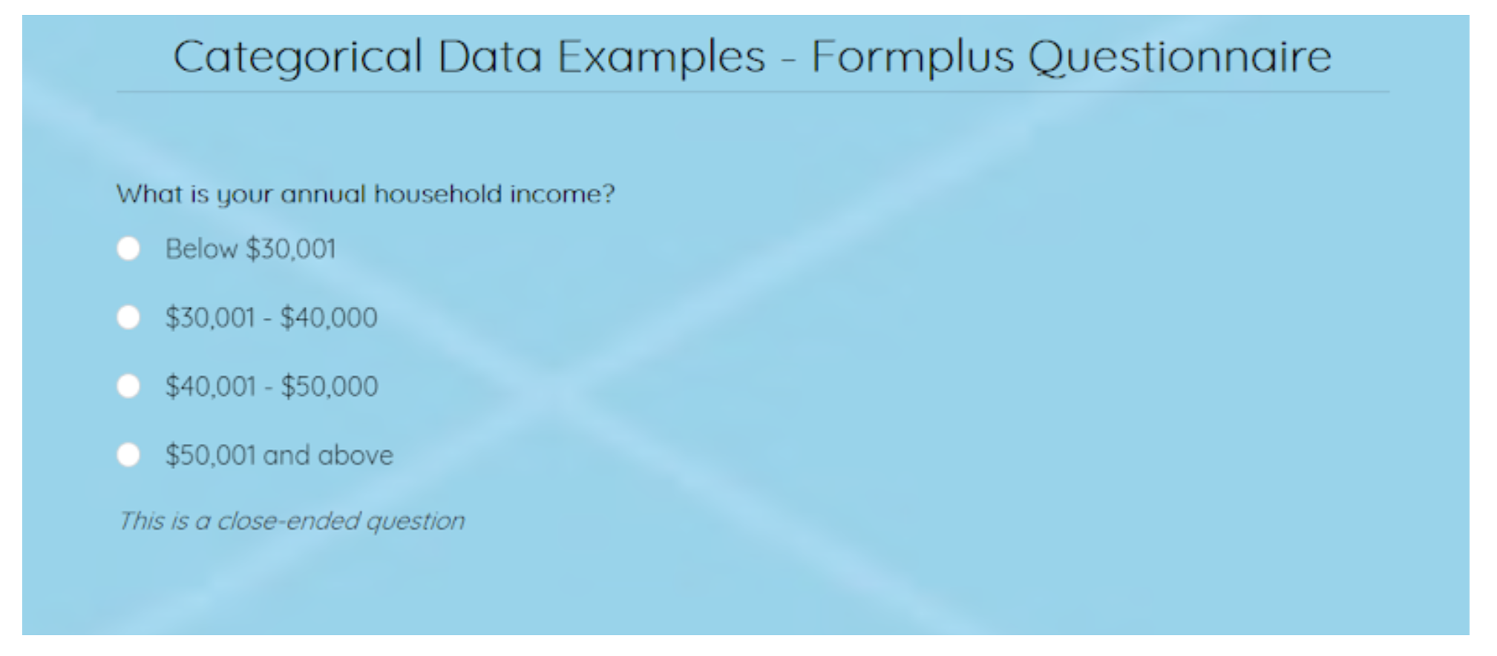

**Education level:** the level of education of a respondent may be requested for when filling forms for job applications, admission, training etc. This is used to assess their qualification for a specific role.

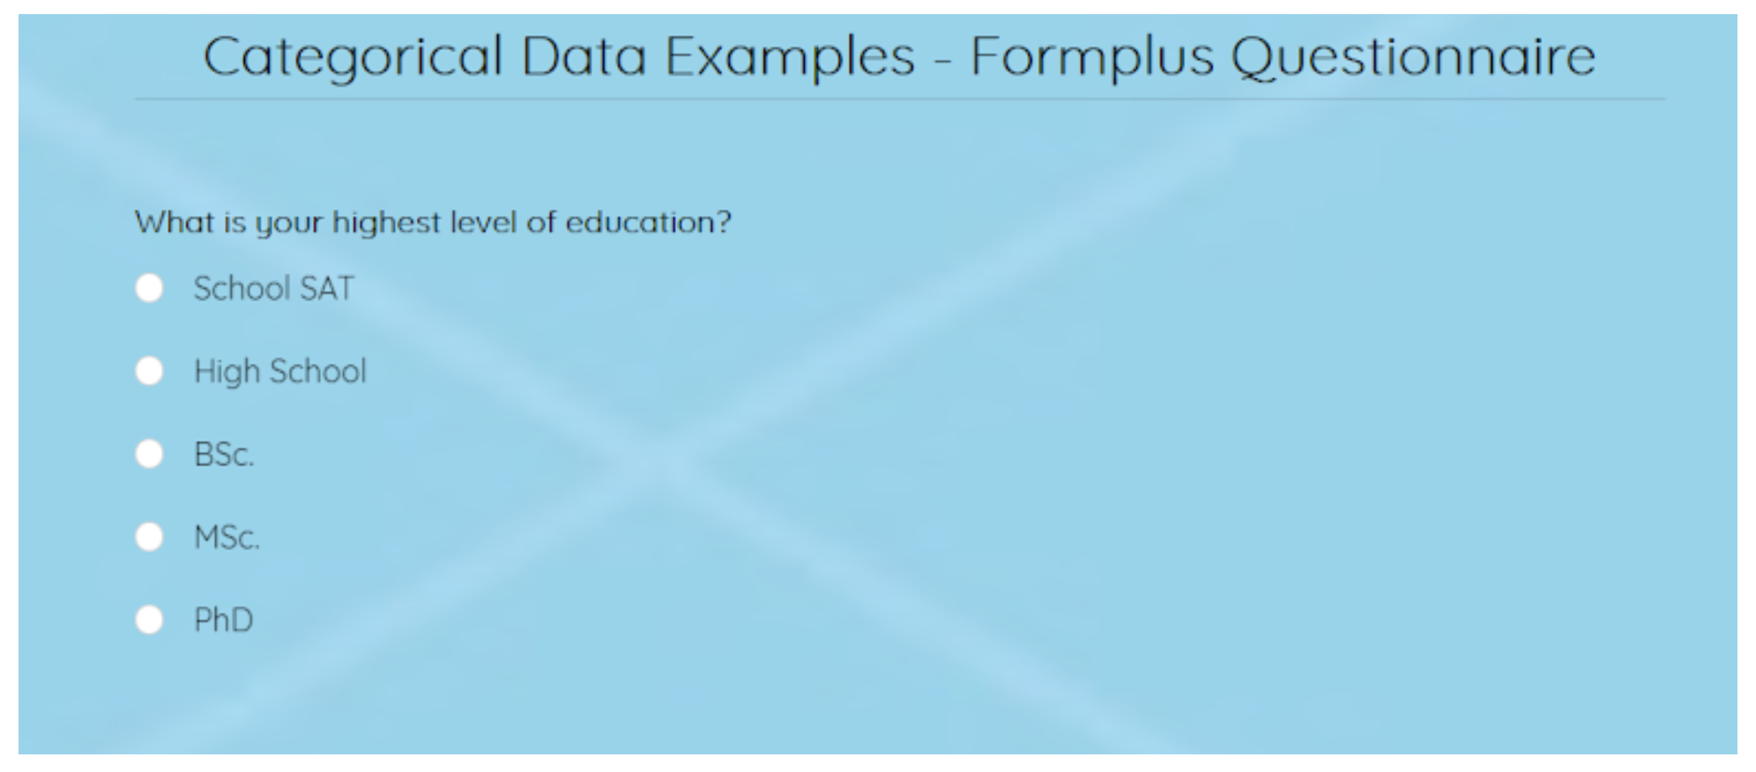

**Gender:** Respondents are asked for their gender when filling out a biodata. This is mostly categorized as male or female but may also be nonbinary.

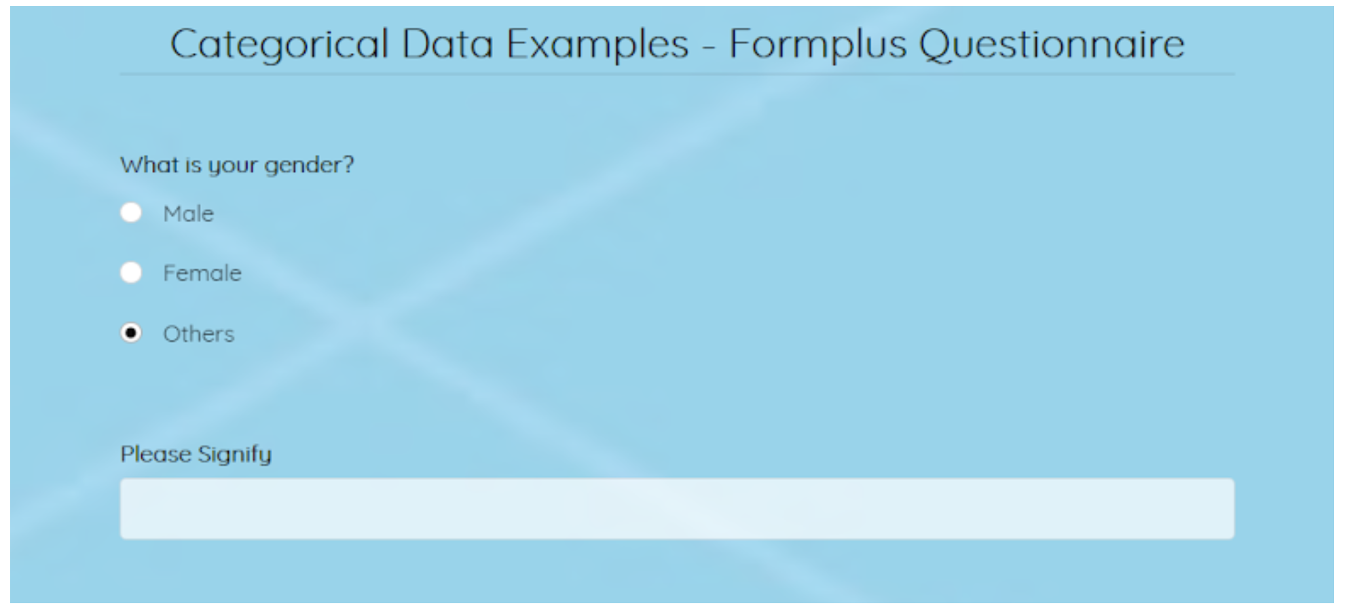

There are few other examples of categorical data in the link here below:

<https://www.formpl.us/blog/categorical-data>

Time Series Data: The visualizations that keep track of time series data are very essential. The performance of a variable over a period. This is also known as temporal visualizations. There are few visualization techniques that explains the visualizations of time series data.

Line Graph: a line graph is the simplest way to represent time series data. It is intuitive, easy to create, and helps the viewer get a quick sense of how something has changed over time. This line graph uses points connected by lines to show how a dependent variable and independent variable changed. Let look at the graph below: which give us the idea of Ireland’s and Europe’s population over a period around 1740 to 2010.

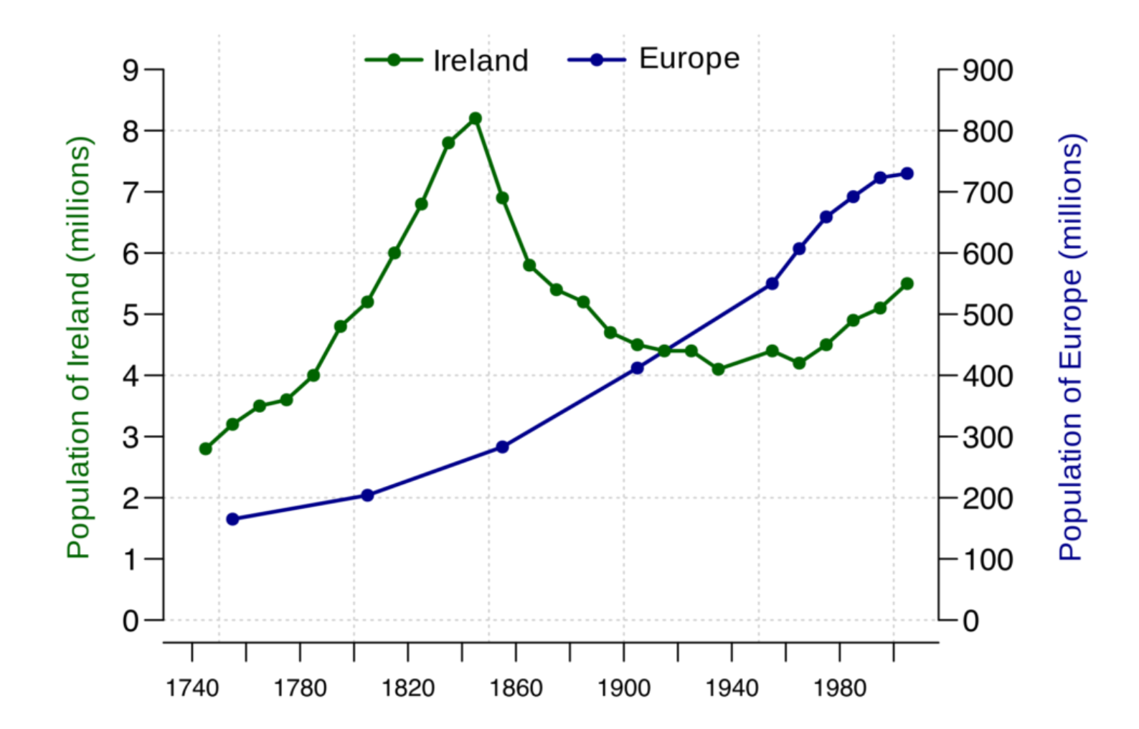

Stacked area chart: An area chart is like a line chart in that it has points connected by straight lines on a two-dimensional chart. It also puts time as the independent variable on the x-axis and the dependent variable on the y-axis. However, in an area chart, multiple variables are stacked on top of each other, and the area below each line is colored to represent each variable. For example let us look into the representation below: which say the representation of number of students in each class range change in over time.

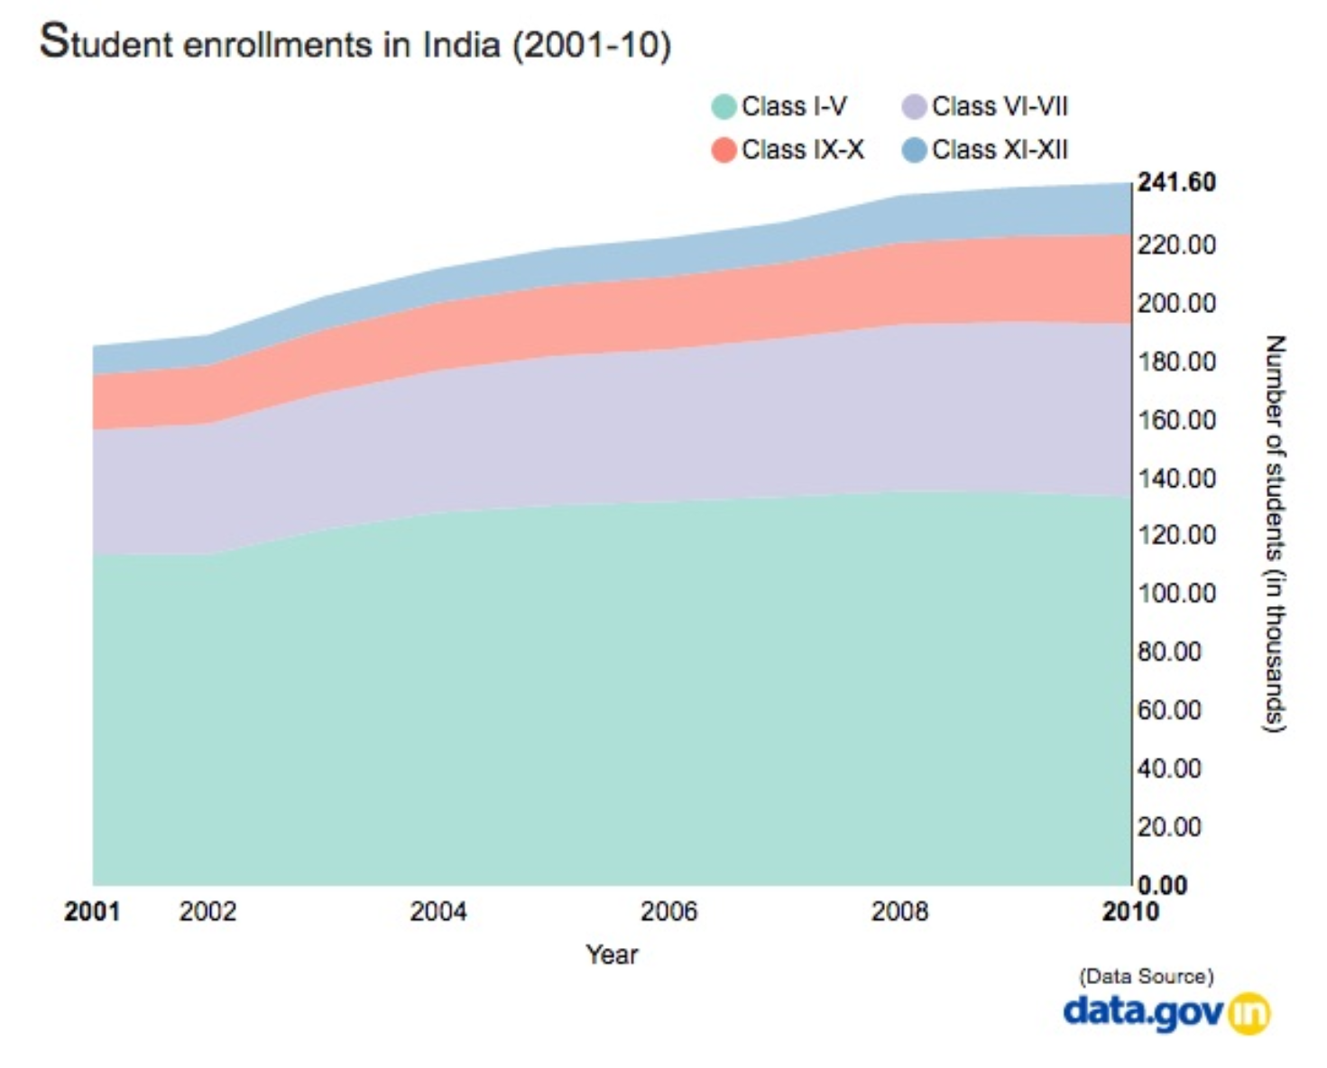

Bar charts: this chart represent data as horizontal or vertical bars. The length of each bar is proportional to the value of the variable at that point in time. A bar chart is the right choice for you when you wish to look at how the variable moved over time or when you which to compare variable versus each other. For instance the below chart says, the number of deaths by type of diseases in India from 2006 – 2011 by different colors for different diseases.

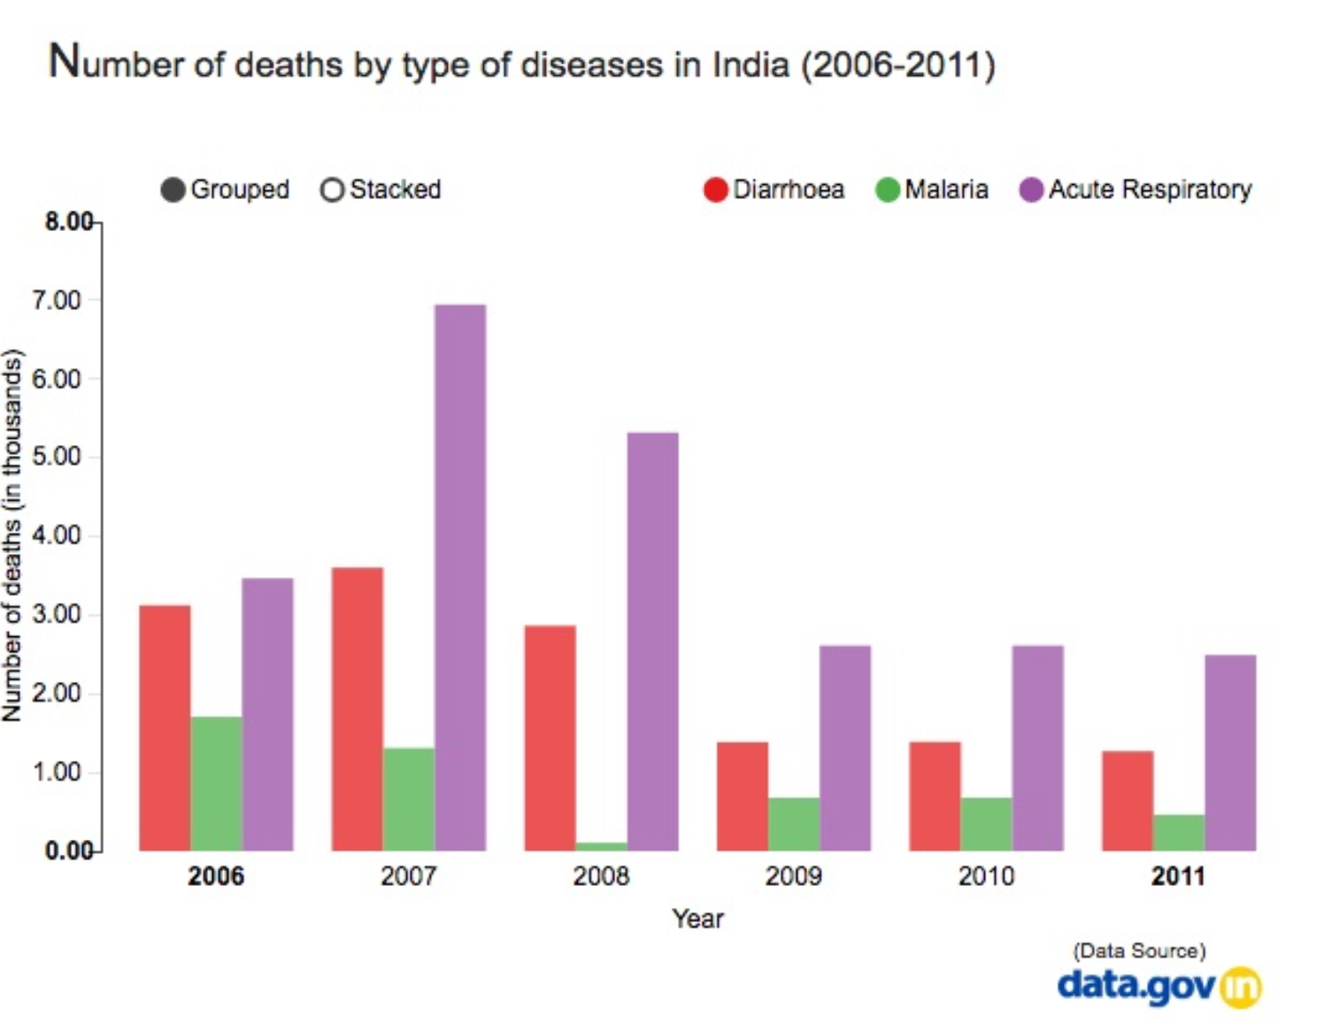

There are many more instances in this time series data in the link below:

<https://humansofdata.atlan.com/2016/11/visualizing-time-series-data/>

Spatial Data Analysis: Most data are related to locations and, therefore, can be placed on the map by using spatial data. Form this approach we can get to know what is present and where it is. The real world can be represented as discrete data, stored by its exact geographic location called feature data, continuous data represented by regular grids called raster data. For instance, the below representation helps us to understand this analysis better, this visualization helps us to understand the deaths per 100,000 for different counties in U.S based on the color representation. Please investigate the link for more detailed information and examples.

<https://www.esri.com/arcgis-blog/products/product/analytics/how-to-perform-spatial-analysis/#:~:text=Spatial%20data%20exploration%20involves%20interacting,and%20insights%20from%20the%20data.>

